Project Design Phase-II
Data Flow Diagram & User Stories

Date | 31 January 2025
Team ID | 6ab3d8050fc666a751b367a2
Project Name | AI StudyBuddy
Maximum Marks | 4 Marks

Data Flow Diagrams (DFD)
A Data Flow Diagram (DFD) is a graphical representation of the flow of information within the AI StudyBuddy – AI-Based Study Planning and Learning Assistance Application. It shows how students interact with the system, how study-related data is processed, how information is stored, and how external services such as the Weather API provide information.
The DFD illustrates how data enters and leaves the application, how it is processed through AI-based study assistance and study planning, and how the results are presented to users. It also helps developers understand the system structure and the relationships between its different components.
The main components of the AI StudyBuddy DFD are:

External Entity: Student

Processes: User Registration and Login, Study Planning, AI Study Assistance, Weather Information

Data Stores: User Database, Study Schedule Database, Task and Reminder Database

External Service: AI Service and Weather API

Example: DFD Level 0 (Industry Standard)
Example: (Simplified)


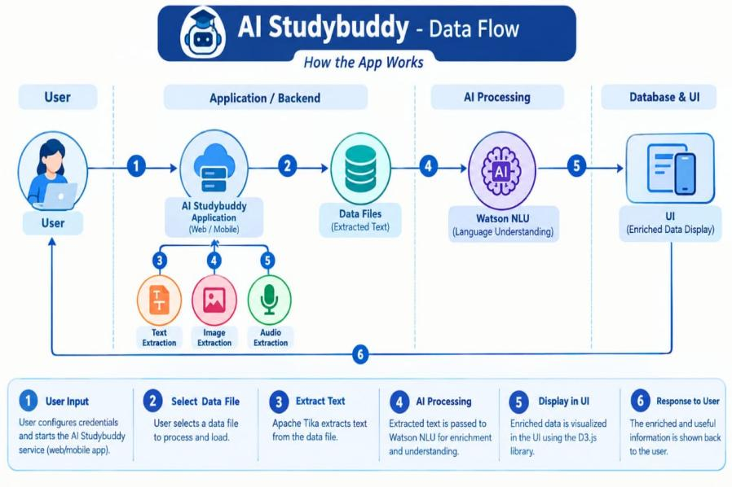

User Stories
Project Name: AI StudyBuddy – AI-Based Study Planning and Learning Assistance Application
User stories describe the features of AI StudyBuddy from the student's and administrator's point of view. Each story includes its functional requirement, acceptance criteria, priority, and planned sprint release.

1. Customer (Student / Web User)

User Type | Functional Requirement (Epic) | User Story Number | User Story / Task | Acceptance criteria | Priority | Release
student | Registration | USN-1 | As a user, I can register for the application by entering my email, password, and confirming my password. | I can create an account using valid details and access the application. | High | Sprint-1
student | login | USN-2 | As a user, I will receive confirmation email once I have registered for the application | I can access my account with valid credentials, and see an error for invalid credentials. | High | Sprint-1
student | dashboard | USN-3 | As a user, I can register for the application through Facebook | I can navigate to study planning, AI assistance, tasks, and weather updates. | high | Sprint-1
student | Study planning | USN-4 | As a user, I can register for the application through Gmail | I can save and view my study schedule. | high | Sprint-1
student | Al study assistance | USN-5 | As a user, I can log into the application by entering email & password | I can submit a question and view a relevant AI response. | High | Sprint-1
student | Ai study suggestion | USN-6 | As a student, I can get AI-based suggestions to help organize my learning. | The application displays study suggestions based on my submitted topic or request. | high | Sprint-2

